2 Minute Form
Trip Name:
Check-in Name and Phone:
Date: Branch:
Leaders
Cell Phone Number
VHF Call Sign &/or Vessel Name
Vehicle make, model, registration, colour
General Plan
Note: If plan changes, you must notify your Check-in person.
Latest Time Off the Water |  |  |  |  | TMP used²⁰
Tide/ Forecast Lake Level | Low |  |  | High | Other
Communications Carried²¹
Communications | We will be communicating as a group on VHF Channel _____
Equipment Carried
Trip Report
(Use other side if more space required)

Activity | Club trip | Centre | Auckland | Location |  |  | Auckland |  | Difficulty¹ |  |  | Beginners+
Activity Description | Launch at the boat ramp at Wenderholm Regional Park. Paddle up the estuary to Puhoi. This can be one way, or return. You can also go in the other direction depending on the tides. |  |  |  | Leader qualification req.² |  | Trip leader
Get in Location | Wenderholm or Puhoi |  |  |  | Chart/ Map no.⁴ |  | 532 |  | Distance |  |  | 9km one way, or 18km return
Get out Location | Wenderholm or Puhoi |  |  |  | Coastguard Channel |  | 82 & 16 |  | Nowcasting |  |  | 20,21,22
Emergency get out ⁵ | Nothing easy – banks are deep mangroves and mud. Part way up there is a jetty near a road that could possibly be used. |  |  |  | Emergency / Coastguard Station |  | Auckland |  | Phone |  |  | *500  09 303 4303
 |  |  |  |  | Drinking Water⁶ | At the pub |  | Toilets⁷ |  |  | Yes
Emergency Response | Refer Emergency Response Booklet |  |  |  |  |  |  | Parking⁸ |  |  | Yes
Specific Equipment Required⁹ | Usual kayaking safety gear |  |  |  | Working Communications equipment in this area¹⁰ | Cell phone  Sat phone |  |  |  | Mountain Radio |  |  | PLB  VHF
Other resources  and notes¹¹ | The Puhoi Pub is very busy on weekends, has a nice outdoor area with tables and umbrellas. Good pub food. This is a very popular trip, very sheltered, and tide assisted.  Take money and change of clothes for the pub. |  |  |  | Weather Parameters¹² | Beginners Wind under 15 knots, no significant surf or swell  Intermediate Wind under 25 knots, & surf or swell less than 1.5 m  Advanced Any condition that is suitable for the trip's aims
Previous incidents¹³

Safety Management¹⁴
Hazard |  | Significant?  - E/I/M |  | Management Strategy¹⁵ |  |  |  | Hazard | Significant?  - E/I/M | Management Strategy¹⁵
Cold Water |  | Yes - M |  | Carry spare dry clothes and shelter |  |  |  | Deep Water | Yes - E | Correctly fit PFDs
Medical Conditions |  | Yes - M |  | - Leader has first aid qualification  - Ask customers about medical conditions |  |  |  | Bad Weather | Yes - M | Understand weather forecasts.  Have back up plans or pull out if necessary
Capsizing |  | Yes - M |  | - Correctly fit PFDs  - Skills at performing rescues. |  |  |  | Heat / Sun | Yes - M | - Protective Clothing (worn), Sunglasses, Hat  - Sun Screen  - Plenty of drinks
Panic |  | Yes - M |  | Ensure conditions match level  of skills |  |  |  | Obstacles | Yes - M | Awareness of reefs, navigational hazards, nets
 |  |  |  |  |  |  |  | Other Vessels | Yes - M | - Understand the “rules of the sea”  - “Be seen” – Have two of the following; flag, brightly coloured kayak, brightly coloured Pfd or hat. At night: an all- round white light & a powerful torch.
Written up by: | Larraine Williams |  | Approved By: |  | Russell Williams | Signed: | RW |  | Date: | 16 May 2014 | Review in: | 12 months from date of approval

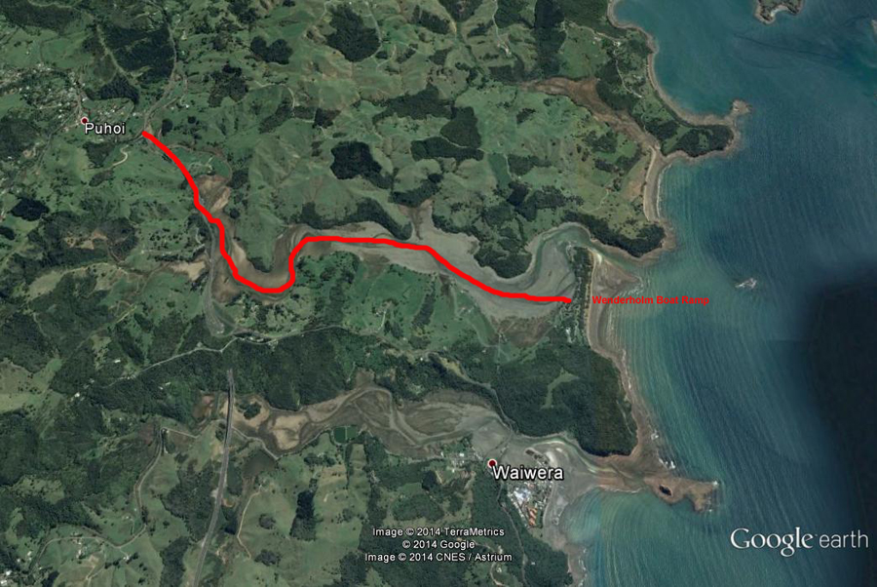
Additional Information Sheet (Optional)
Introduction (A general introduction)
Description (A description of the tour – as if you were selling the idea to someone)
Local Attractions |  | Transport/ Local Operators
 | Contact details |  | Contact details
Local Eateries
 | Contact details
Accommodation/ Campsite Locations |  |  | Facilities
Name |  |  | Cabins |  | Fuel
Phone |  |  | Showers |  | Power
E-mail |  |  | Toilets |  | Water Access
Website |  |  | Laundry |  | Pool
Physical Address |  |  | Water |  | Fires Allowed
Other |  |  | Supplies
Other information

Activity Equipment Check list
Equipment List
- Helmet (rivers & surf) Group Gear
❑ Beanie / hat  Split paddles
❑ Thermals  Repair kit
❑ Paddle Jacket  Fire lighting
❑ PFD  Cooker/thermos
❑ Spray deck  Spare thermals
❑ Booties  Tow system
❑ Water & food  1st Aid Kit
❑ Kayak & paddle  Flares
Group - Oceans & Lakes  Compass
❑ Pumps & Paddle Floats  Charts / Maps
Group - River  GPS (optional)
❑ Throw ropes  Knife (cut rope)
❑ Pin kit & saw  Emergency Shelter

In case of emergency: Dial 111, Mayday :VHF Channel 16

Kayaking Check list

❑ Trip plan
❑ Latest weather forecast
❑ Conditions match skills?
❑ Hyperthermia (hot) &
Hypothermia (cold)
❑ On & off water safety
❑ Environmental concerns
❑ Emergency Procedures include emergency get out.
❑ Working communication devices
e.g. VHF radio, mobile phones, PLB
❑ Specific safety issues for this trip
❑ Participant list
❑ Any medical conditions
❑ All participants keen to proceed?

❑ Trip Plan/ 2-minute form lodged with Ops. Manager

Appropriate wind conditions to run trips:
Novice - no significant surf or swell, wind under 15knots
Intermediate- surf or ocean swells less than 1.5 meter or wind under 25 knots.
Advanced- any condition that is suitable to the trips aims

At conclusion of trip:
Contact check in person
Group Debrief.

Check in Person Ph:
__________________ Mobile
__________________ Work
__________________ Home

Activity Document Cover Sheet

Activity:
Date of Activity:

Activity reports. Is all relevant information present:
– Approved Trip Management Plan (TMP)/ 2 minute form
– Club Trip Participant Sheet
– Weather forecast
– Activity Check List
– Trip report (May be on the 2 minute form)
– Accident / incident reports
Leaders Signature:
Date:

